Chapter 10, Problem 84.

Obtain V_{o} in the circuit of Fig. 10.126 using PSpice.
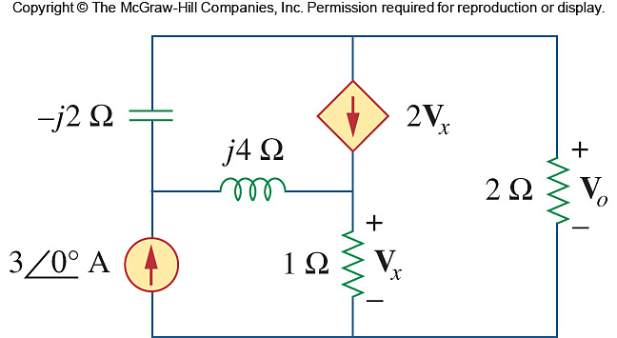

Figure 10.126
For Prob. 10.84.

